Project Design Phase
Solution Architecture

Date | 09 September 2026
Team ID | SWUID2026190415
Project Name | Medical Diagnosis Center by Service Portal (ServiceNow)
Maximum Marks | 4 Marks

Solution Architecture:
Solution architecture describes how the Medical Diagnosis Center application is designed and how different components work together on the ServiceNow Platform. It connects business requirements such as patient registration, diagnostic test booking, report management, payment tracking, and workflow automation with technical implementation.
Its goals are to:
- Find the best ServiceNow solution to manage diagnostic center operations digitally.
- Describe the structure and working flow of the application to stakeholders.
- Define application features, workflows, database tables, and development phases.
- Provide a scalable and secure healthcare management solution on the ServiceNow platform.
Example - Solution Architecture Diagram:
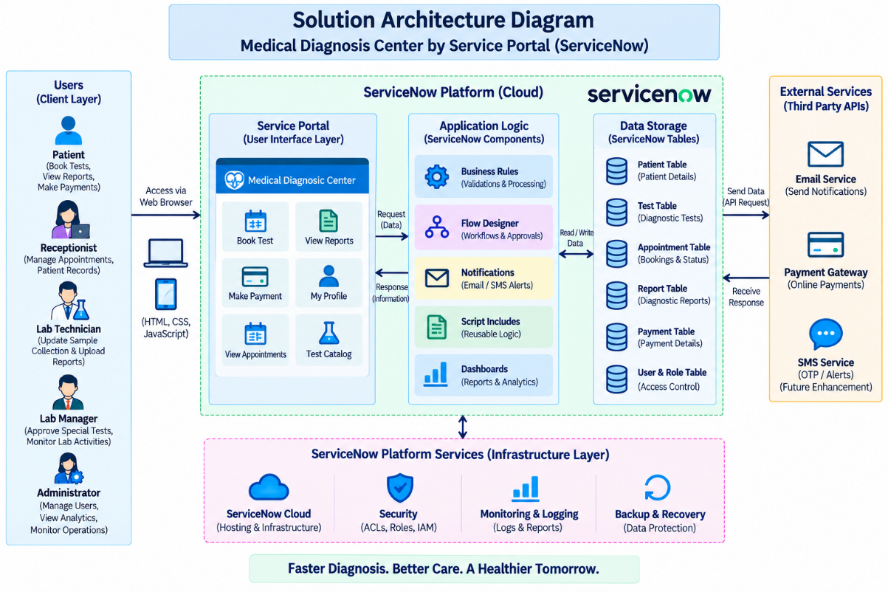

Figure 1: Architecture and data flow of the Medical Diagnosis Center sample application
Reference: https://aws.amazon.com/blogs/industries/voice-applications-in-clinical-research-powered-by-ai-on-aws-part-1-architecture-and-design-considerations/

